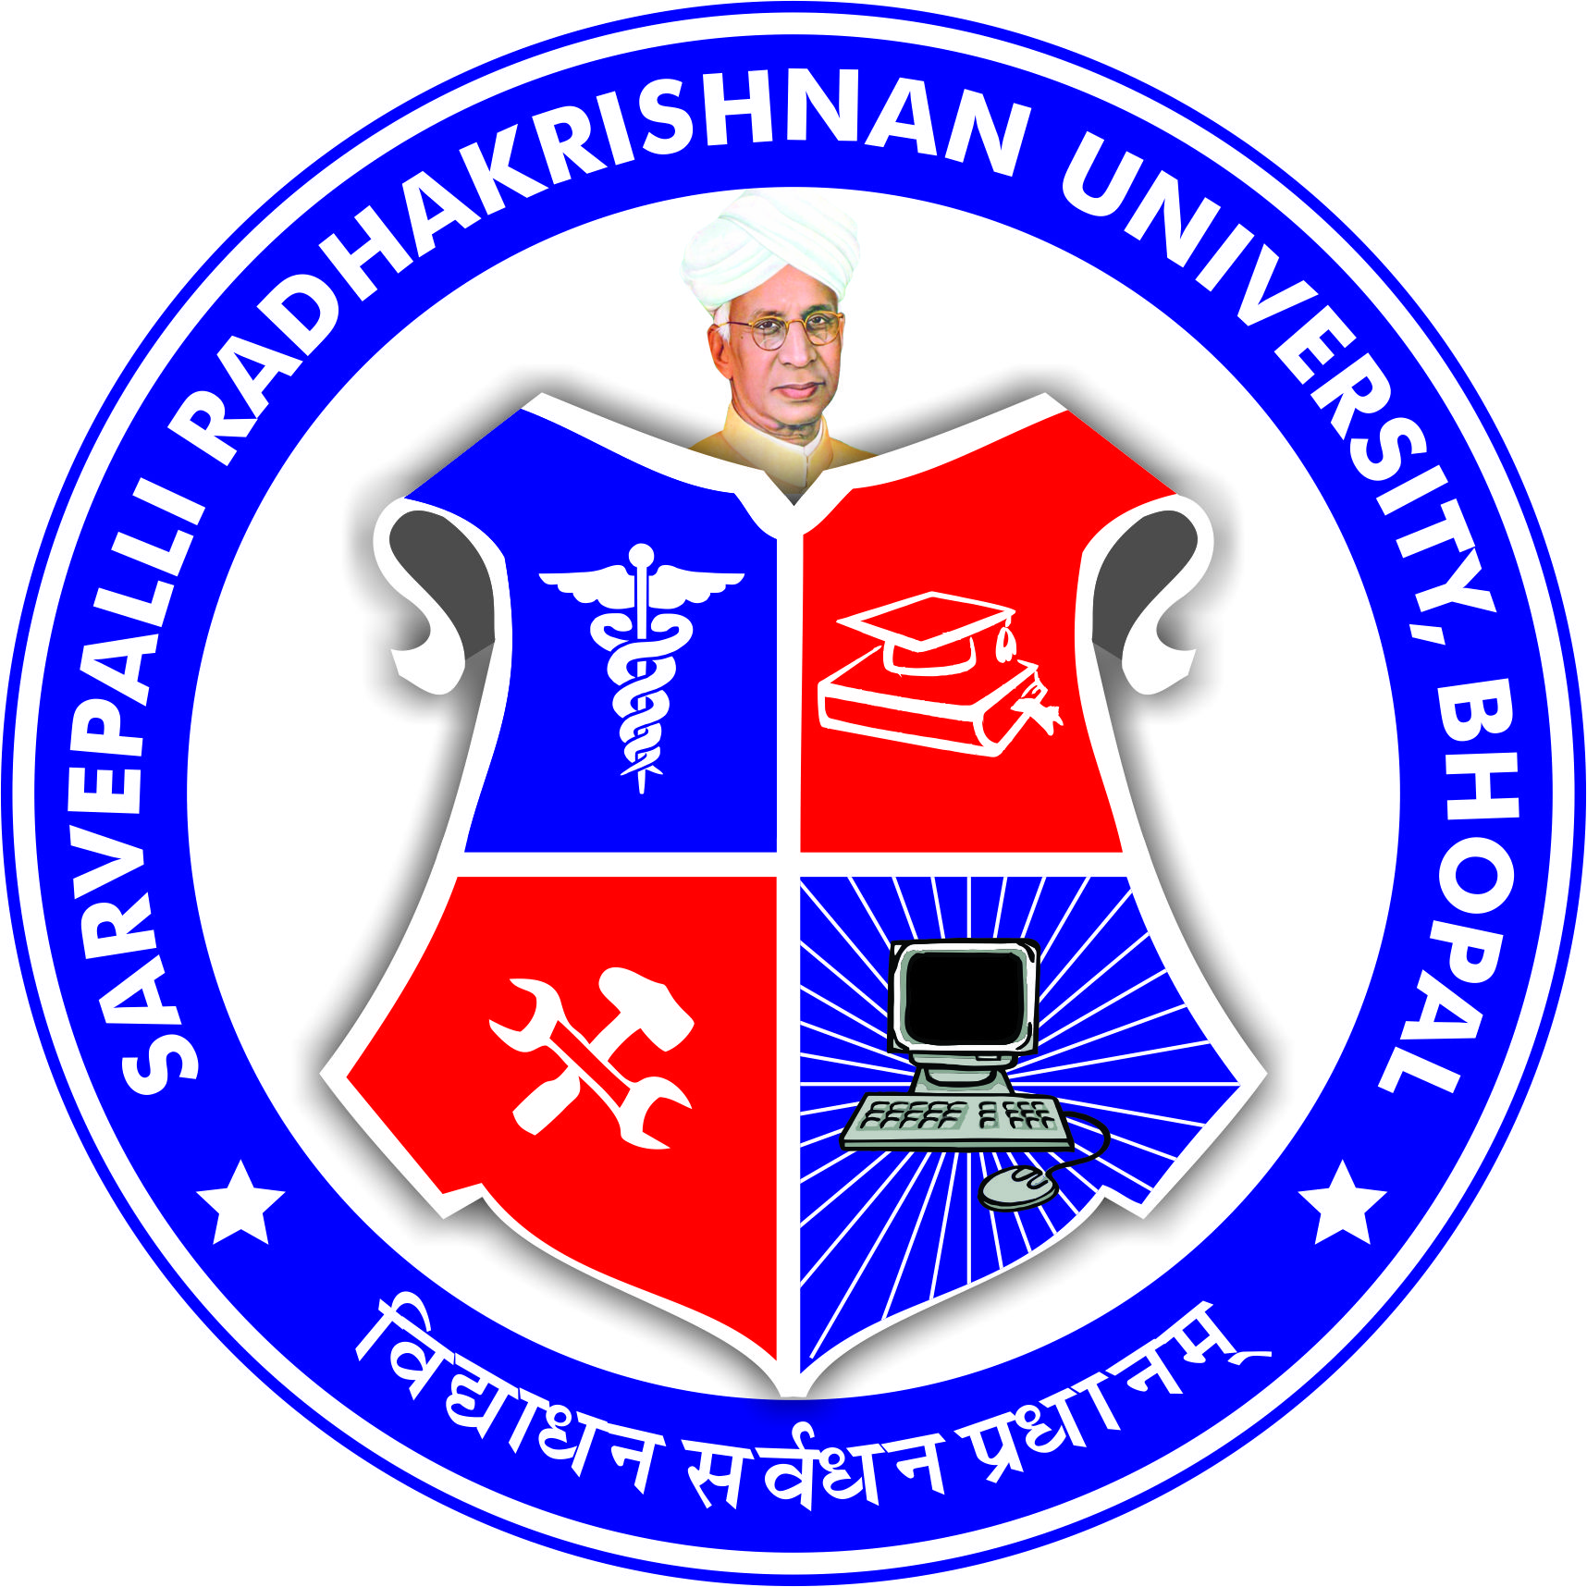
SARVEPALLI RADHAKRISHNAN UNIVERSITY
NH 12,RKDF IST CAMPUS, HOSHANGABAD ROAD, MISROD, BHOPAL (M.P.)
¼Statutory University established by Govt. of M.P. under section 2(F½ of UGC act)
www.srku.edu.in, info@srku.edu.in,Phone: 0755-4700981 Fax: 07554700981

No. Date
Internal complaints committee
It is notified that, the Vice Chancellor, in exercise of the provisions contained in the UGC (prevention, prohibition and redressal of sexual harassment of women employees and student in higher education institutions) Regulations 2015, hereby constitute the Internal complaints committee of Sarvepalli Radhakrishnan University, Bhopal as under-
S.No. | Name & Designation | position
1. | Dr. Archana Selvan  Prof. RKDF College of Nursing | Presiding Officer
2. | Dr. Varsha Namdeo  Prof. Department of Computer Science Engineering | Member
3. | Dr. Brijendra Singh  HOD Department of Paramedical Sciences | Member
4. | Dr. Bharti Chourasiya  Prof. Department of Engineering | Member
5. | Dr. Bhavika Bhavsar  Prof. RKDF Dental College & Research Center | Member
6. | Dr. Jyoti Yadav  Asstt. Prof. Department of Civil Engineering | Member
7. | Ms. Shweta Singh  B. Tech. CSE 3rd year Student | Member
8. | Ms. Sameeksha Palande  BHMS 3RD Year Student | Member

Registrar

